HAND DELIVERED or REGULAR MAIL
March 9, 2017

Name
Address
City, State Postal Code

RE: Appointment – Probationary

Dear Name:
I am pleased to welcome you to Washington State University (WSU) and look forward to you joining the Area/College. Below is information regarding your appointment.
Title: Official Title/Title Code

Location: This is a Civil Service position located on the Pullman campus of WSU [alter to specific location plus potential assignment other location/campus as required]

Reports to: Name, Title / Phone

Salary: Range xx, Step A, $x,xxx.00 per month

Appointment status: xx FTE (40 hr/wk)

Overtime Eligibility: Overtime Ineligible – You are to document leave activity by completing and certifying the Leave Report as described in the Business Policies and Procedures Manual 60.63. OR Overtime Eligible – You are to track hours worked and leave taken by completing and certifying the Time Report as described in the Business Policies and Procedures Manual 60.60.

Schedule: Monday through Friday; 8:00am – 5:00pm

Effective Date: Month, Date, Year

On Date at Time you are to report to Name, in the Location Name Room number.
Included with this letter is a copy of your position description and performance expectations. Please sign and return them to Name.

During the first six (6) months of your appointment, you will serve a probationary period in accordance with Washington Administrative Code 357-19. Additional information on probationary periods is available at the Human Resource Services website, hrs.wsu.edu.
Washington State University employs only U.S. citizens and lawfully authorized non-U.S. citizens. This offer is contingent upon you securing, prior to the start of your employment, appropriate visa status and work authorization. All new employees must show employment eligibility verifications as required by the U.S. Citizenship and Immigration Service to comply with the Immigration Reform and Control Act. See the enclosure for types of documentation required. You will need to show this documentation to your department office within three (3) business days after duties begin. Failure to do so will result in termination of employment.

[Select language regarding orientation – two samples are provided below.]
Sample 1
I have scheduled you OR you will be scheduled to attend New Employee Orientation on Day, Date, Month, at Time, in Building Room # and Employee Retirement Orientation on Day, Date, Month, at Time, in Building Room #. New employee information is available through the Human Resource Services website hrs.wsu.edu/neo.

Sample 2
You are encouraged to attend New Employee Orientation and Employee Retirement Orientation. New employee information, including benefits, is available through the Human Resource Services website hrs.wsu.edu/neo.

As a new WSU employee you will be required to complete training regarding prevention of discrimination and sexual harassment within six months of your date of hire. Information regarding this training is available at the following web site: hrs.wsu.edu/dshp.
[If appointment is to a supervisory/management position include:]
You will be required to attend the Supervisory Training series. Enrollment and schedule information is available through the Human Resource Services website hrs.wsu.edu/supervisory.

WSU is committed to providing equal opportunity in education and employment, and in all aspects of university activities. A critical element of our commitment to diversity lies in our ability to collect and assess student and employee demographic data. Your response to the voluntary WSU Employee Demographic Information Survey would be very helpful in our efforts to create a rich and inclusive community for all at WSU. Visit the Office for Equal Opportunity’s website at oeo.wsu.edu/eeo-aa-compliance/ for more information and to complete the survey.

We look forward to you joining Department.

Sincerely,

[A list of appointing authorities can be found at hrs.wsu.edu/managers/appointing-authority/]
Appointing Authority Name
Title

Encl: U.S. Citizenship and Immigration Services required documentation
Important Benefits Information

cc: Appropriate Area/Department Representative(s)
HRS Personnel File
HRS Employment Services Unit

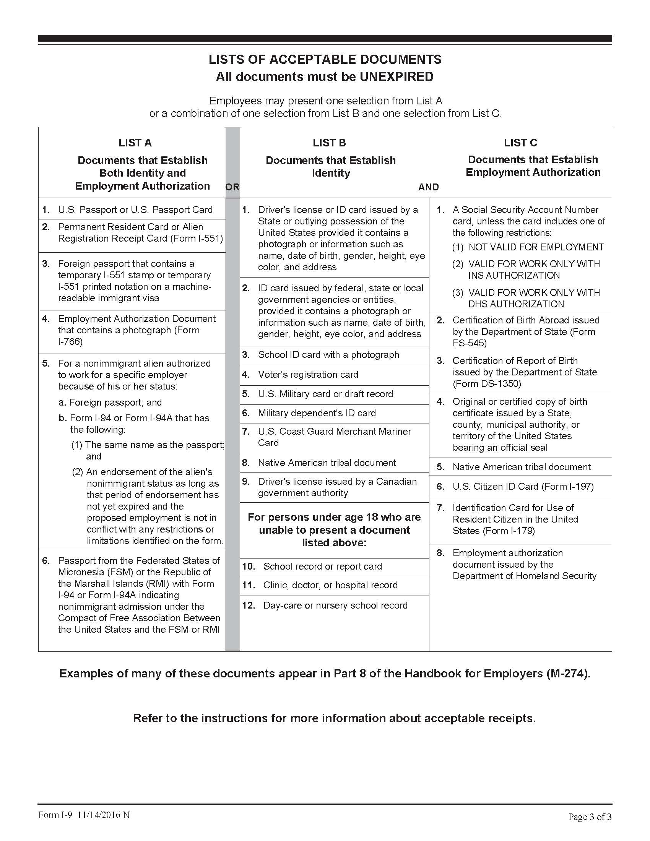

Important Benefits Information for New Employees

Welcome to Washington State University!

Human Resource Services (HRS) has been informed that you have recently been offered employment with WSU. As a new employee, you will have benefit options which need to be addressed, primarily within the first 30 calendar days from your hire date.

New Employee Benefit Information
In an effort to provide you with this information as soon as possible, we would like to direct you to the HRS Benefits website at hrs.wsu.edu/employees/benefits/new-employee-information/.

This webpage provides valuable information for you to review in order to begin making your benefit decisions. In the event you would like to complete and submit benefit forms early, the forms are also linked on this webpage. Additionally, the New Employee Resources link will provide you with a schedule of the new employee orientations, where helpful information and resources for new employees are provided.

New Employee Benefits Packet
In addition to this web link, HRS Benefits will mail you a new employee packet which will include hard copies of the materials found at the above link. This packet will also include information about your retirement plan options. Although retirement plan resources are available online, please be aware that many factors are used to determine which plan an employee is eligible for. If you wish to address your retirement benefits prior to receiving the packet, please contact HRS at (509) 335-4521 or hrs@wsu.edu.

If you have not received a benefits packet within two weeks of your hire date, please contact HRS immediately. Packets are also available at the HRS office, located in 139 French Administration in Pullman. For locations other than Pullman, please contact us at (509) 335-4521 or hrs@wsu.edu.

Dual Enrollment
In the event you are already enrolled on a spouse’s, registered domestic partner’s, or parent’s Public Employee Benefit Board (PEBB) coverage, dual enrollment in WSU medical/dental coverage is not allowed. Both you and the individual on whom you already have coverage will need to complete benefit paperwork. Additional details will be available in the benefit packet. Contact HRS with questions about dual enrollment, and the paperwork that needs to be completed.

Again, Welcome to WSU! If you have questions please contact Human Resource Services at (509) 335-4521 or hrs@wsu.edu.

