Cost Sharing Documentation Requirements for Manual Entries

Salaries (00) and Benefits (07) cost share for WSU employees is entered through the Effort Certification process. See WSU BPPM 40.35 for instructions on how to complete the Effort Certification Report.

All other cost share involves manual entries – a memo from the department initiates the documentation process needed by Sponsored Programs Services to place all other cost share manually into the system.

- Cost share memos must come from a person with expenditure authority on the project or the PI and must include the following information:
- Grant account with cost share obligation (account where cost share is being tracked)
- Account where the costs were incurred
- Dollar amount(s)
- Transaction details (vendor name, date, etc.)
- Document number(s) if applicable
- All cost share transactions must be incurred within the period of performance of the award.

TUITION WAIVERS: A memo from the department providing the waiver including the dollar amount, dates, name and WSU ID # of person receiving the waiver along with a print out of their myWSU account showing the tuition was paid.

FACILITIES AND ADMINISTRATIVE COSTS (F&A): SPS is responsible for posting waived F&A and additional F&A adjustments. Departments are responsible for reviewing the information for accuracy. Contact accountant and CC sps@wsu.edu for any questions regarding discrepancies.

WAGES (Object 01): The department must complete the “Manual Cost Share Data sheet” (attachment #10) listing all pay periods separately. The form should include benefits (object 07) and F&A (object 13), if allowable by agency. This sheet is also used for cost sharing salaries expensed more than two years out. NOTE: This is only done as an exception and must include a justification as to why it wasn’t entered in a timely manner on the Effort Certification Report.

Pay rates need to be reasonable and justifiable per the award document or other recognized source. Volunteers should attest to the hours donated by signing documentation such as a time card. This is considered in-kind cost sharing. If a retired WSU employee is providing volunteer labor as cost share, use their last salary rate to compute the cost share amount but do not include benefits or F&A.

THIRD PARTY cost sharing:
- A cover memo prepared by the department and signed by someone with expenditure authority on the grant or by the PI.
- The original letter of commitment, and
- A letter is required from the donor, which states the dollar amount (or value for in-kind), the time-period during which the match was provided and signed by an authorized individual from the donor’s business or contracts office. This is entered into the system as 03 in-kind

COST SHARE PROVIDED BY SUBCONTRACTORS should be included with their invoices. SPS enters the cost share into the system once the invoices is approved for payment and returned to SPS by the department.

Fund 143 is Federal Appropriations and may not be used as cost share.

WSU Source Cost Sharing Example (Attachments #1-4):

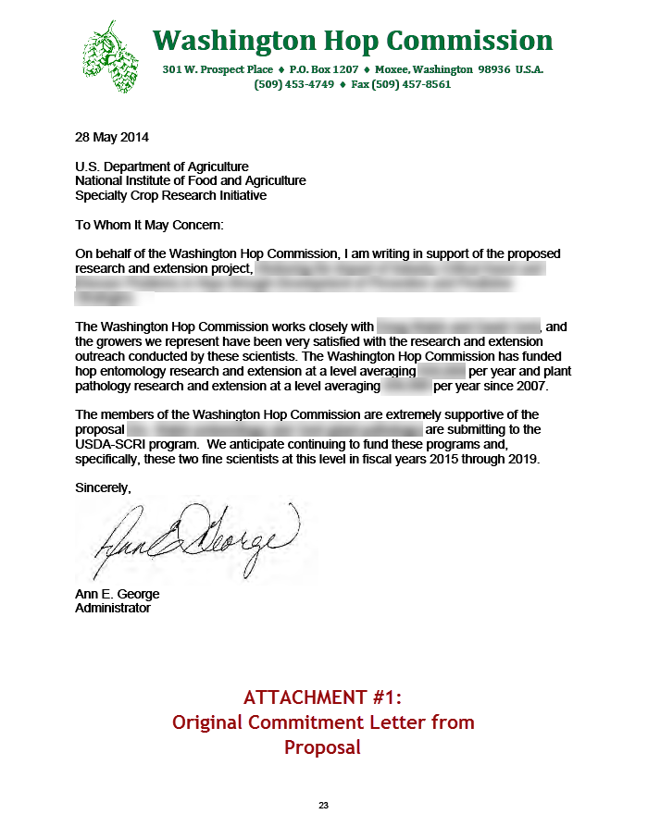

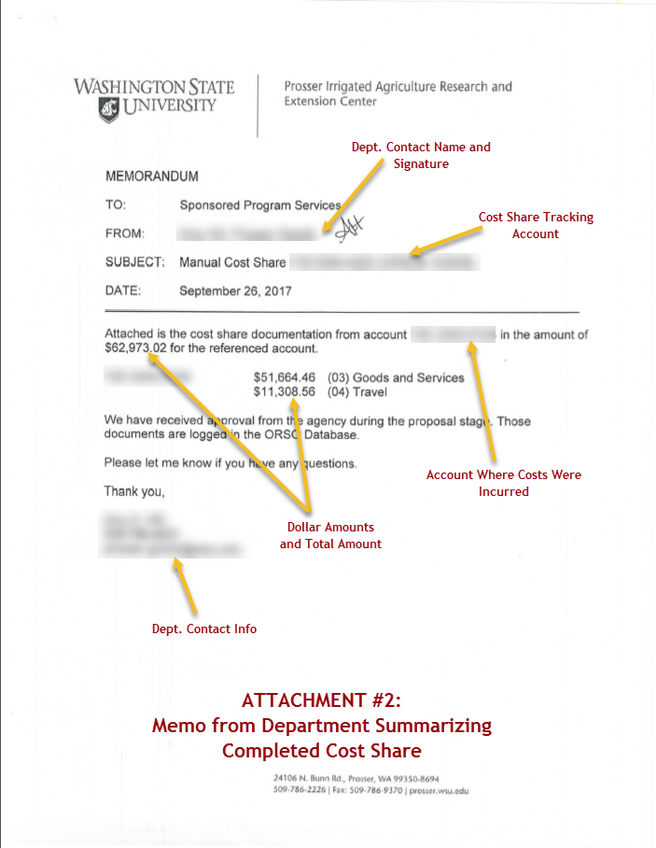

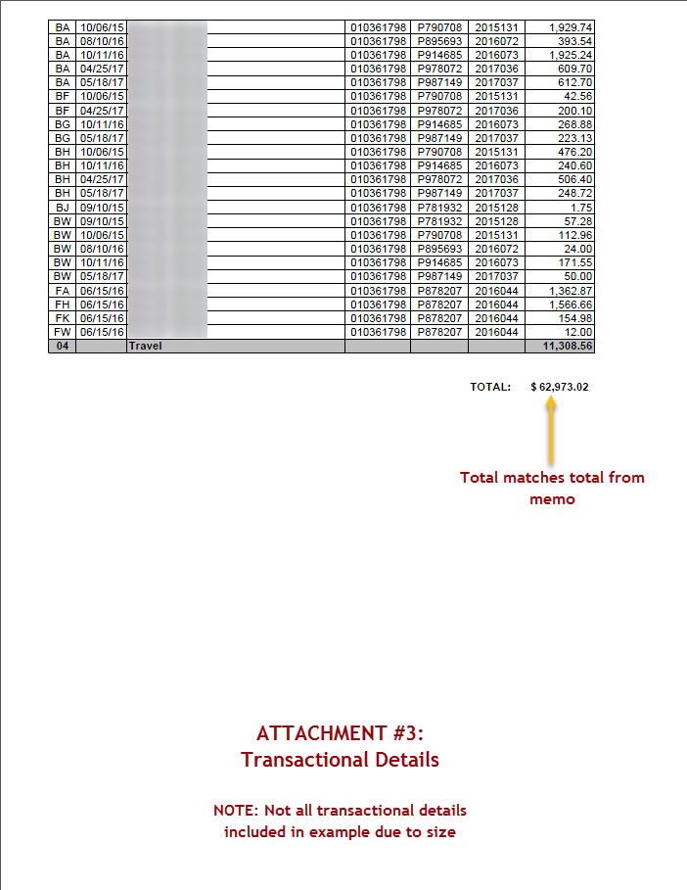

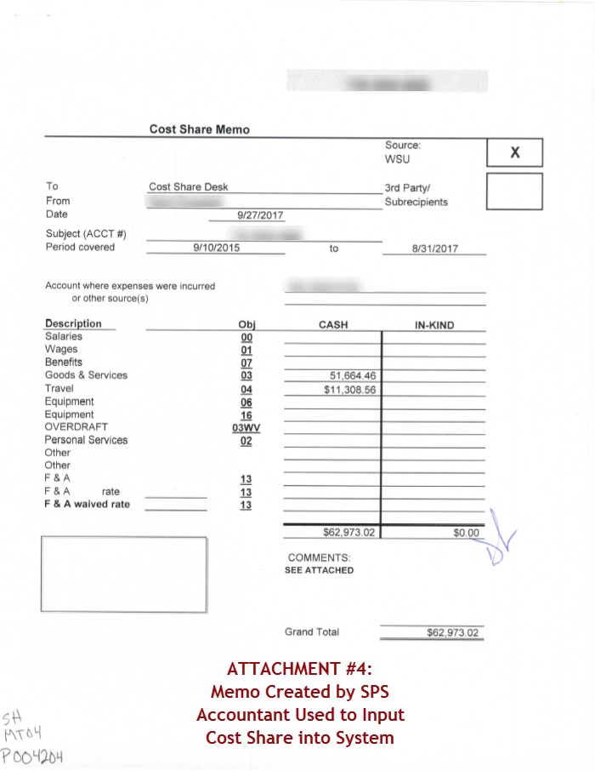

WSU Third Party Cost Sharing Example (Attachments #5-9):

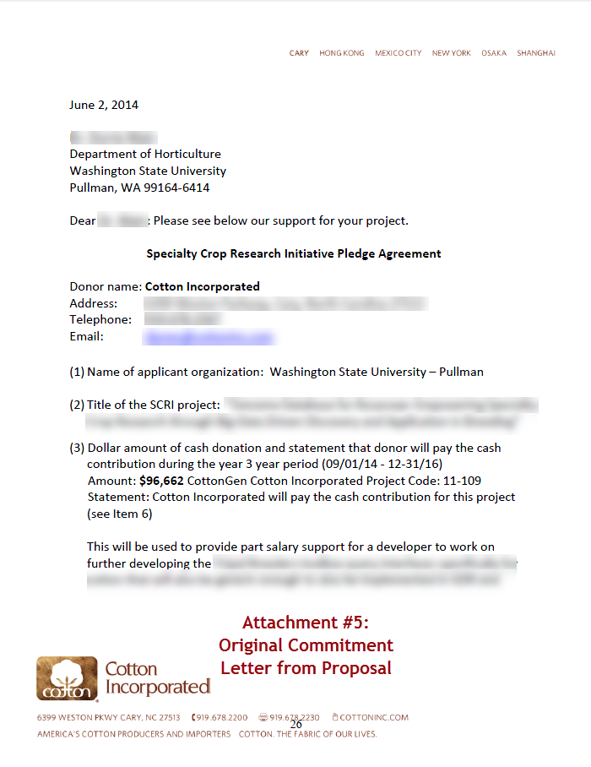

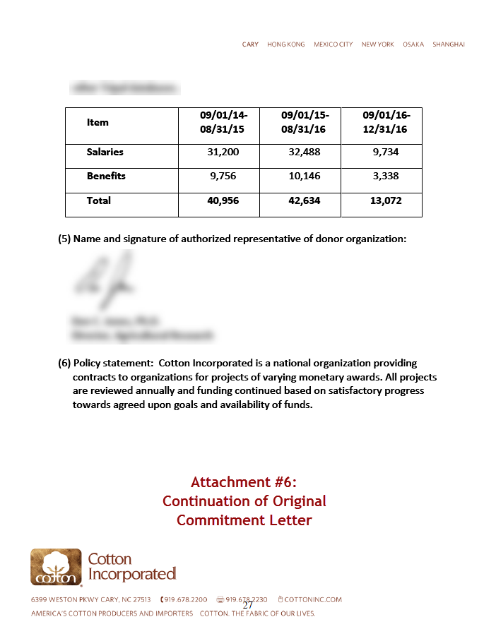

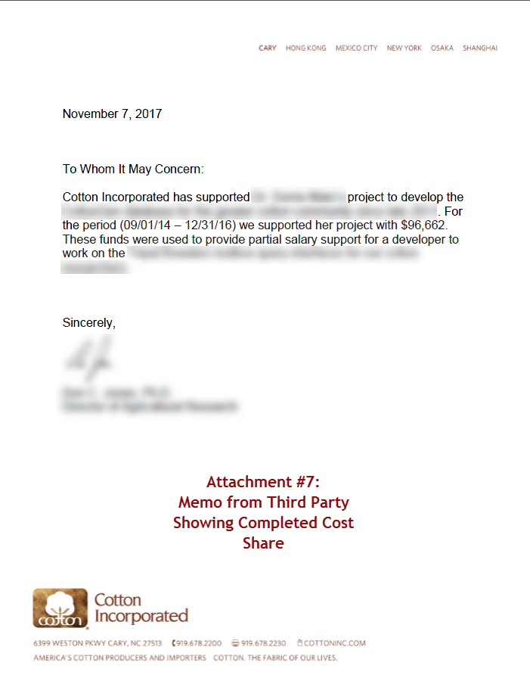

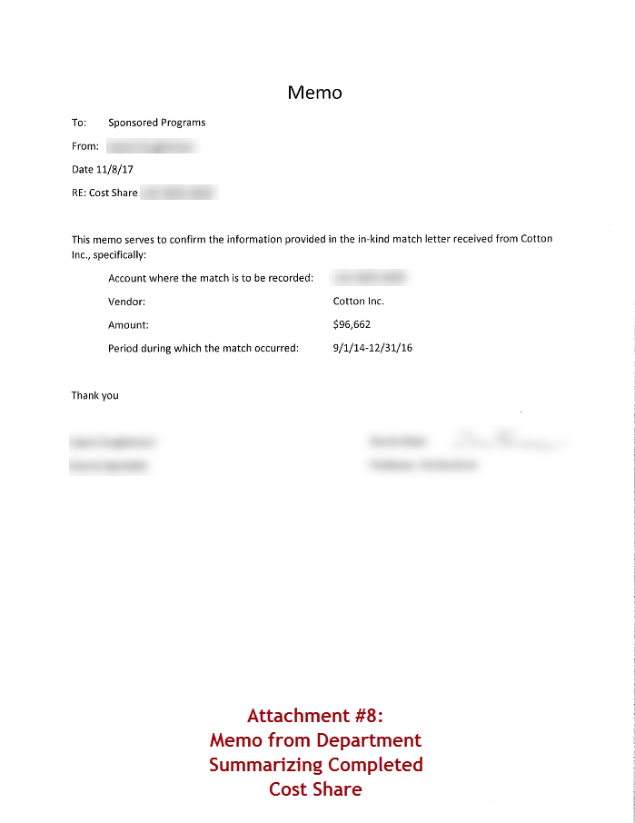

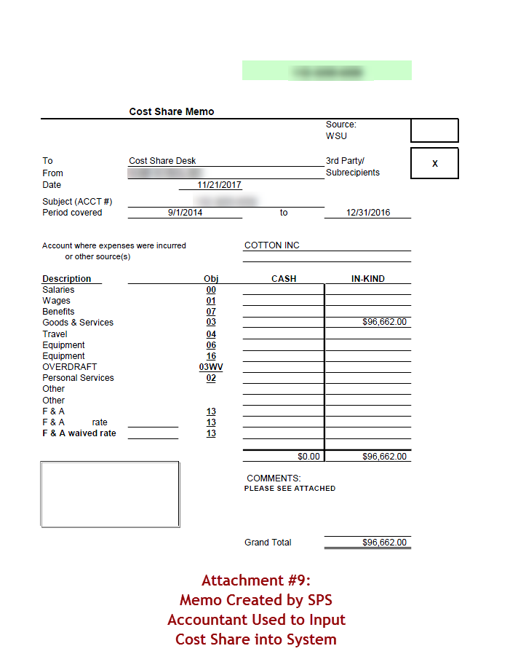

Manual Cost Share Data Sheet (Attachment #10):

