Name: ___________________________________________________________________________
Date:
Activity One (ACAD_PROG)
Create a query that returns the following information:
- Total number of undergraduate students who currently have an Active Program on the Pullman campus.
- Please include only the following fields in results:
  - EMPLID
  - ADMIT_TERM
- Query Type: User
- Owner: Private
- Folder: Save in folder defined as your First and Last Name; for example BILL_THOMPSON
Answer: ____________________

Create a query that returns the following information:
- Total number of undergraduate students who had an Active Program on the Pullman campus as of January 1, 2016.
- Please include only the following fields in results:
  - EMPLID
  - ADMIT_TERM
- Query Type: User
- Owner: Private
- Folder: Save in folder defined as your First and Last Name; for example BILL_THOMPSON
Answer: ____________________

Activity Two (STDNT_CAR_TERM)
Create a query that returns the following information:
- Total number of students Term Activated for Fall 2017.
- Please include only the following fields in results:
  - EMPLID
  - ACADEMIC_LOAD
- Query Type: User
- Owner: Private
- Folder: Save in folder defined as your First and Last Name; for example BILL_THOMPSON
Answer: ____________________

Create a query that returns the following information:
- Total number of students Term Activated for Fall 2017 who either cancelled or withdrew from the term.
- Please include only the following fields in results:
  - EMPLID
  - ACADEMIC_LOAD
- Query Type: User
- Owner: Private
- Folder: Save in folder defined as your First and Last Name; for example BILL_THOMPSON
Answer: ____________________

Activity Three (STDNT_ENRL)
Create a query that returns the following information:
- Total number of students enrolled in Fall 2017
- Query Type: User
- Owner: Private
- Folder: Save in folder defined as your First and Last Name; for example BILL_THOMPSON
Answer: _____________

Create a query that returns the following information:
- Total number of students enrolled by Academic Career in Fall 2017
- Query Type: User
- Owner: Private
- Folder: Save in folder defined as your First and Last Name; for example BILL_THOMPSON
Career: _____________ Number of Enrolled Students: _____________
Career: _____________ Number of Enrolled Students: _____________
Career: _____________ Number of Enrolled Students: _____________
Career: _____________ Number of Enrolled Students: _____________
Career: _____________ Number of Enrolled Students: _____________
Career: _____________ Number of Enrolled Students: _____________
Career: _____________ Number of Enrolled Students: _____________

Activity Four (CLASS_TBL)
Create a query that returns the following information:
- Total number of distinct subject-catalog number combinations for active lecture courses as of the beginning of the Fall 2017 term.
- Query Type: User
- Owner: Private
- Folder: Save in folder defined as your First and Last Name; for example BILL_THOMPSON
Answer: ____________________

Activity Five (CLASS_TBL)
Create a query that returns the following information:
- Total number of distinct subject-catalog number combinations for active lecture classes as of the beginning of the Fall 2017 term.
- Query Type: User
- Owner: Private
- Folder: Save in folder defined as your First and Last Name; for example BILL_THOMPSON
Answer: ____________________

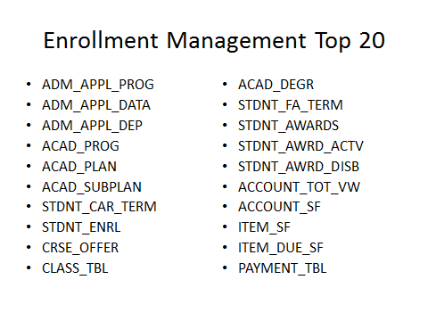
STDNT_ADVISOR and STDNT_ADVR_HIST (the Advisor ID lives in STDNT_ADVR_HIST)

