Name: ___________________________________________________________________________
Date:
Activity One (ACAD_PROG)
Create a query that returns the following information:
Total number of undergraduate students who currently have an Active Program (AC) on the Pullman campus (Campus = PULLM).
- Please include only the following fields in results:
  - EMPLID
  - ADMIT_TERM
- Query Type: User
- Owner: Private
- Folder: Save in folder defined as your First and Last Name; for example BILL_THOMPSON
Answer: _______________________

Modify the query so that it returns the following information:
- Total number of undergraduate students who had an Active Program on the Pullman campus with an effective date of January 1, 2016.
- Please include only the following fields in results:
  - EMPLID
  - ADMIT_TERM
- Query Type: User
- Owner: Private
- Folder: Save in folder defined as your First and Last Name; for example BILL_THOMPSON
Answer: ____________________

Activity Two (STDNT_CAR_TERM)
Create a query that returns the following information:
- Total number of students Term Activated for Fall 2017.
- Please include only the following fields in results:
  - EMPLID
  - ACADEMIC_LOAD
- Query Type: User
- Owner: Private
- Folder: Save in folder defined as your First and Last Name; for example BILL_THOMPSON
Answer: ________________________

Modify the query so that it returns the following information:
- Total number of students Term Activated for Fall 2017 who either cancelled (CAN) or withdrew (WDR) from the term.
- Please include only the following fields in results:
  - EMPLID
  - ACADEMIC_LOAD
- Query Type: User
- Owner: Private
- Folder: Save in folder defined as your First and Last Name; for example BILL_THOMPSON
Answer: ________________________

Activity Three (STDNT_ENRL)
Create a query that returns the following information:
- Total number of students enrolled in Fall 2017 who have not withdrawn or dropped. Criteria (Enrollment status = E and Status Reason not “WDRW”)
- Please include only the following fields in results:
  - EMPLID
- Query Type: User
- Owner: Private
- Folder: Save in folder defined as your First and Last Name; for example BILL_THOMPSON
Answer: _________________

Modify the query so that it returns the following information:
- Total number of students enrolled by Academic Career (UGRD, GRAD, BUSN, PHAR, VETM, MEDS, IALC) in Fall 2017 who have not withdrawn or dropped.
- Query Type: User
- Owner: Private
- Folder: Save in folder defined as your First and Last Name; for example BILL_THOMPSON
Career: _________________ Number of Enrolled Students: __________________
Career: _________________ Number of Enrolled Students: _________________
Career: _________________ Number of Enrolled Students: ________________
Career: _________________ Number of Enrolled Students: _________________
Career: _________________ Number of Enrolled Students: _________________
Career: ________________ Number of Enrolled Students: ______________
Career: ________________ Number of Enrolled Students: _____________

Activity Four (CLASS_TBL)
Create a query that returns the following information:
- Total number of distinct subject and catalog number (select as fields) combinations for active lecture (courses for Fall 2017 term.
- Use the following criteria SSR_COMPONENT = LEC
- Query Type: User
- Owner: Private
- Folder: Save in folder defined as your First and Last Name; for example BILL_THOMPSON
Answer: _______________________

Activity Five (CLASS_TBL, STDNT_ENRL)
Create a query that returns the following information:
- Total number of distinct students (use EMPLID, subject and catalog number as fields) enrolled in class number 3470 who have not withdrawn or dropped for Fall 2017 term.
- Query Type: User
- Owner: Private
- Folder: Save in folder defined as your First and Last Name; for example BILL_THOMPSON
Answer: _______________________

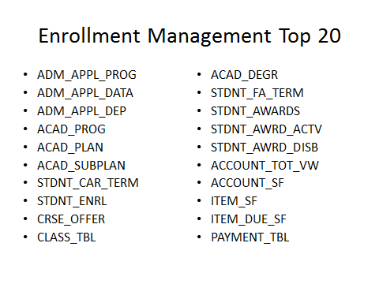
STDNT_ADVISOR and STDNT_ADVR_HIST (the Advisor ID lives in STDNT_ADVR_HIST)

