Add Delivery Method
March 9, 2021

Name
Address
City, State Postal Code

RE: Non-tenure, Career Track Faculty Appointment

On behalf of the Area/College, I am pleased to offer you an appointment with Washington State University (WSU). The terms of the offer are as follows:

Title | Title Code: Official Career Track title | Title Code

Working Title: Add if applicable

Position Number: Position Number

Location: This position is located on the Name campus of WSU. [alter to specific location plus potential assignment other location/campus as require]

Appointment: The appointment is a 9-month academic, [Continuous] non-tenure, Career track faculty rank.
[Insert if applicable: 12-month annual, [Continuous], non-tenure, Career track faculty rank]

FTE: 100% Full-time equivalency (FTE)

Salary: $xx,xxx on an annual/academic year basis (or $#,### monthly)

Effective Dates: The Continuous Career Track appointment will be effective August 16, YEAR. As a 9-month academic position, each year the career track appointment will be effective August 16 - May 15. OR As a 12-month annual position, each year the career track appointment will be effective July 1 – June 30.

[If you have a 1-year appointment, then only add the actual dates.] The career track appointment is effective August 16, YEAR through May 15, YEAR.

[If for more than a 1-year appointment] The length of appointment is x year(s). As a 9-month academic position, each year the Career Track appointment will be effective August 16 - May 15. OR As a 12-month annual position, each year the career track appointment will be effective July 1 – June 30.

In accordance with the WSU Faculty Manual, Section III.E.1, this appointment will end on the date specified unless positive action is taken to renew your appointment. Subsequent renewals are subject to satisfactory performance, mutual consent, and available funding. [Insert if on an Annual Appointment: Accumulated annual leave must be used prior to the termination date, unless you obtain a written exception from your appointing authority.]

Start-up: [Insert details of start-up package, including the date by which the funds must be expended and contact information for any questions. Indicate the location of the laboratory, if there is a laboratory and if the location is known. Be sure to indicate that this is the “current” lab space. Please indicate that start-up funds must be spent according to current University rules.]

Workload: Your workload distribution is approximately x% effort teaching, x% research, and x% service. Please note teaching loads and additional duties may change over time depending on the needs of the Unit, the College, and the University. If a course is cancelled, your workload may be adjusted and/or your FTE, and you will be notified as soon as possible. Significant changes in expectations will be communicated to you in writing.

[Insert details of moving expenses, if applicable] The department will provide relocation compensation in the amount of $#,### in accordance with university policy and subject to appropriate payroll taxes. In accordance with BPPM 55.62, if you terminate your employment or cause termination with WSU for reasons other than disability separation, or other good cause, within one year of your employment date, you will be responsible for repaying the department the full amount of your relocation compensation.

WSU employs only U.S. citizens and lawfully authorized non-U.S. citizens. All new employees must provide identity and employment eligibility verifications as required by the U.S. Citizenship and Immigration Service to comply with the Immigration Reform and Control Act. See the attached List of Acceptable Documents. You must complete Form I-9 no later than the first day of employment and provide acceptable documents no later than the third business day of employment.

The current Faculty Manual, in its current form and as it may be revised in the future, is a primary resource for policies and procedures regarding faculty, and its provisions are conditions of employment. The Faculty Manual should be consulted and followed in resolving questions regarding your appointment. You may access the Faculty Manual at the following website: facsen.wsu.edu.

The Washington State University Intellectual Property policy, which is included in the Faculty Manual and is a condition of your employment, provides that certain intellectual properties developed within the scope of the faculty members’ employment or association, or developed with substantial use of university facilities, or developed under third party funding agreements are considered to be the property of the University. By your acceptance of this position, you hereby assign to the University any intellectual property in which the University has an interest, as defined by the Faculty Manual, and further agree to execute promptly all assignments, waivers and other legal documents necessary to vest in the University or its assignee any and all rights to the intellectual property.

[The paragraph is optional: Current university policy allows faculty members to devote the equivalent of one day per week for each week worked to private consulting activities.
Consulting must not interfere with the faculty member’s normal duties, must not cause a conflict of interest, and must be consistent with state law and university policy. Consulting activities must be approved by, and disclosed promptly to, the department chair or school director and reported annually, on a standard form, to the chair/director, dean and provost.

[Insert this paragraph for all appointments less than 100% and for only one semester] PEBB Benefit Eligibility Information: Human Resource Services (HRS) will review your appointment to determine if you are eligible for benefits. If ineligible, you will be notified via the conditions statement on your Personnel Action Form. If eligible, you will receive an informational packet from HRS-Pullman.

You may access PEBB rules and guidance on this decision through the PEBB website, pebb.hca.wa.gov, specifically WAC 182-12-114 (employee eligibility for benefits) and 182-12-131 (maintaining the employer contribution). If you have a change that affects your eligibility for benefits, HRS will notify you. You may ask HRS to re-evaluate your eligibility at any time.

HRS offers New Employee Orientation and Employee Retirement Orientation sessions for new employees. Please attend orientations to comply with benefit enrollment deadlines. New Employee Orientation schedules are located on the HRS website, hrs.wsu.edu/neo. To assist you in making your transition to the university, you will be registered to attend New Faculty Orientation. This year’s orientation will be held in Pullman on Date. Please contact your department chair/school director for details of the schedule.

As a new WSU employee, you will be required to complete training regarding prevention of discrimination, sexual misconduct prevention and sexual harassment within six months of your date of hire. Information regarding this training is available at the following web site: hrs.wsu.edu/dshp.

WSU is committed to providing equal opportunity in education and employment, and in all aspects of university activities. A critical element of our commitment to diversity lies in our ability to collect and assess student and employee demographic data. Your response to the voluntary WSU Employee Demographic Information Survey would be very helpful in our efforts to create a rich and inclusive community for all at WSU. Visit the Office of Compliance & Civil Rights’ website at ccr.wsu.edu/eeo-aa-compliance for more information and to complete the survey.

The faculty and staff of the College/Department are delighted you have chosen to pursue your career at Washington State University. Please return a signed copy of this letter indicating if you accept or decline this offer of appointment to Name, Title, Mailing Address. We need your original acceptance to place in the permanent university records and to approve your name for the university payroll. A reply is requested at your earliest convenience, but no later than Date. Please retain a copy of the letter for your records.

Sincerely,

Chair/Director Name, Title Appointing Authority Name, Title
Department/School Name College of Name
[A list of appointing authorities can be found at hrs.wsu.edu/appointing-authority]

Campus Appointing Authority Name, Title
Name of Campus
[A list of appointing authorities can be found at hrs.wsu.edu/appointing-authority]

Encl: U.S. Citizenship and Immigration Services required documentation
Important Benefit Information

cc: Appropriate College/Department representative(s)
HRS Personnel File
HRS Employment Services Unit
HRS Benefit Services

Accept Decline

Signature Date
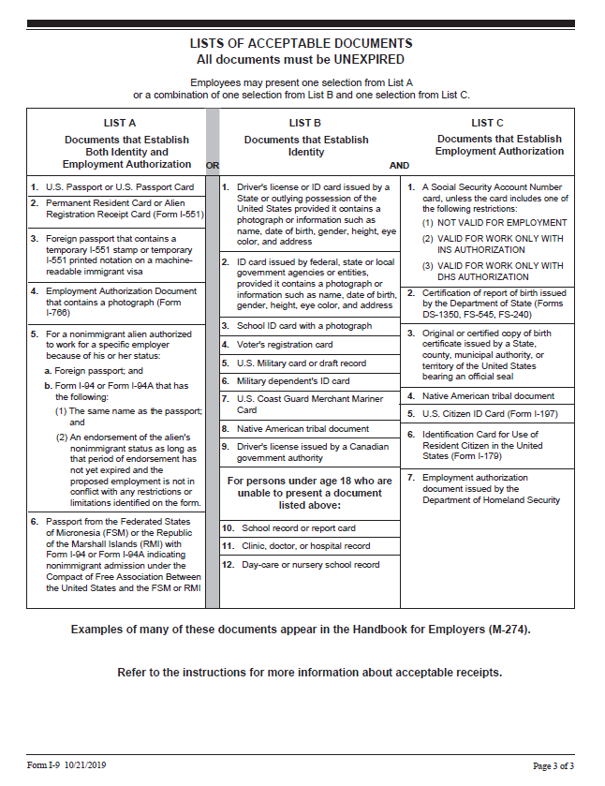

Important Benefits Information for New Employees

Welcome to Washington State University!
Human Resource Services (HRS) has been informed that you have recently been offered employment with WSU. As a new employee, you will have benefit options which need to be addressed, primarily within the first 30 calendar days from your hire date.

New Employee Benefit Information
In an effort to provide you with this information as soon as possible, we would like to direct you to the HRS Benefits website at hrs.wsu.edu/new-employee-information.

This webpage provides valuable information for you to review in order to begin making your benefit decisions. In the event you would like to complete and submit benefit forms early, the forms are also linked on this webpage. Additionally, the New Employee Resources hrs.wsu.edu/new-employee-resources website will provide you with a schedule of the new employee orientations, where helpful information and resources for new employees are provided.

New Employee Benefits Packet
In addition to this web link, HRS Benefits will mail you a new employee packet which will include hard copies of the materials found at the above link. This packet will also include information about your retirement plan options. Although retirement plan resources are available online, please be aware that many factors are used to determine which plan an employee is eligible for. If you wish to address your retirement benefits prior to receiving the packet, please contact HRS at (509) 335-4521 or hrs@wsu.edu.

If you have not received a benefits packet within two weeks of your hire date, please contact HRS immediately. Packets are also available at the HRS office, located in 139 French Administration in Pullman. For locations other than Pullman, please contact us at (509) 335-4521 or hrs@wsu.edu.

Dual Enrollment
In the event you are already enrolled on a spouse’s, registered domestic partner’s, or parent’s Public Employee Benefit Board (PEBB) coverage, dual enrollment in WSU medical/dental coverage is not allowed. Both you and the individual on whom you already have coverage will need to complete benefit paperwork. Additional details will be available in the benefit packet. Contact HRS with questions about dual enrollment, and the paperwork that needs to be completed.

Again, Welcome to WSU! If you have questions please contact Human Resource Services at (509) 335-4521 or hrs@wsu.edu.

