Hand Delivered or Regular and Electronic Mail
April 30, 2021

Name
Address
City, State Postal Code

Dear [Dr. /Mr. /Ms. Name]:

On behalf of Washington State University (WSU), the [School/Department name] and the [College name], we are pleased to offer you a [9-month academic/12-month annual] appointment as [title/title code/position number] at [location] at a salary of [$] per academic year/year, (or [$] per month), with a start date of [date]. Your appointment is for a [full-time/part-time] position and is categorized as tenure-track.

[Insert this paragraph for those who have not completed their Ph.D. at time of hire: If we do not receive confirmation that you have completed your Ph.D. by August 15, year, your appointment will be as a Lecturer and your salary will be $[$reduced amount] per academic year until we receive confirmation that your Ph.D. is complete. The Lecturer appointment is temporary and will end May 15, year, [maximum 1-year] unless positive action is taken by the [School/Department name] and [College of name] to extend your appointment.

[Insert this paragraph for those who will hold an additional title: In addition to your Assistant/Associate/Professor appointment, you will also hold the title of [Title] in [School/Department Name] for a term of [years], starting [date] and ending [date].

Tenure-track and tenured faculty members in the School/Department and College at Washington State University are expected to teach and advise students at both the undergraduate and graduate levels; conduct a program of independent, collaborative, and/or cross-disciplinary peer-reviewed research and scholarship; pursue internal and external grant funding; and provide service to the department, college, university, public and/or profession. Please note you may be asked to conduct instructional assignments face to face or over electronic media and that assignments to teach specific courses may vary from year to year depending on the needs of the School/Department and/or College. [Insert more specific information when available. For example, “The current teaching load in [name] School/Department is [number of courses or credits] per semester. You may take a one course reduction in any semester during your first three years on the faculty.” If your college specifies workloads, please add that sentence here. For example, “Your current workload distribution will be approximately --% teaching, --% scholarship, and --% service.”] Expectations for performance may change over time. Significant changes in expectations will be communicated to you in writing.

[Insert this paragraph for those coming in with a normal pre-tenure period for Academic Appointments: “Under current policy you will be eligible for consideration for tenure no later than your sixth full year of employment academic year [date i.e. 20XX], with tenure if granted, effective August 16, (year). Progress toward tenure is evaluated and faculty members are given feedback annually with a more intensive review in the third year. Your third-year intensive review will be completed in Spring [date i.e. 20XX]. Consideration for an early tenure decision is possible pending the support of the Director/Chair, Dean, and Provost. If tenure is awarded early, promotion to associate professor will be awarded at the same time.”]

[Insert this paragraph for those coming in with a normal pre-tenure period for Annual Appointments: “Under current policy you will be eligible for consideration for tenure no later than your sixth full year of employment annual year [date i.e. 20XX], with tenure if granted, effective July 1, (year). Progress toward tenure is evaluated and faculty members are given feedback annually with a more intensive review in the third year. Your third-year intensive review will be completed in Spring [date i.e. 20XX]. Consideration for an early tenure decision is possible pending the support of the Director/Chair, Dean, and Provost. If tenure is awarded early, promotion to associate professor will be awarded at the same time.”]

[Insert this paragraph for those coming in with fewer than the usual number of years until tenure: “Under current policy, faculty members are eligible for consideration for tenure no later than their sixth full year of employment. Progress toward tenure is evaluated and faculty members are given feedback annually with a more intensive review in the third year. In recognition of prior service, you will be considered early for tenure in academic year [date 20XX-20XX] and your third-year intensive review will be completed in [date]. Consideration for an earlier tenure decision is possible pending the support of the Director/Chair, Dean, and Provost. If tenure is awarded earlier, promotion to associate professor will be awarded at the same time.”]

Your tenure and promotion progress will be evaluated according to the guidelines set forth in the University Faculty Manual and in the Departmental and the College Tenure and Promotion Guidelines. The departmental and college guidelines are enclosed. Quality and quantity of performance are both considered when assessing progress towards tenure and/or promotion. The level of expectations may also change over time. Please consult your mentors and members of your department for further specification of current expectations.

[Insert details of start-up package, including the date by which the funds must be expended and contact information for any questions. Indicate the location of the laboratory, if there is a laboratory and if the location is known. Be sure to indicate that this is the “current” lab space. Please indicate that start-up funds must be spent according to current University rules.]

[Insert details of moving expenses if there are any. Refer to BPPM 55.62 regarding eligibility for relocation compensation. The university will provide relocation compensation in the amount of $X,XXX.XX in accordance with university policy and subject to appropriate payroll taxes. In accordance with BPPM 55.62 if you terminate your employment or cause termination with WSU for reasons other than disability separation, or other good cause within one year of your employment date, you will be responsible for repaying the University the full amount of your relocation compensation.

To assist you in making your transition to the University, you have been registered to attend New Faculty Orientation. This year’s Orientation will be held in Pullman on [date]. Please contact your [department chair/school director/academic director] for details or questions.

Human Resource Services (HRS) offers New Employee Orientation and Employee Retirement Orientation sessions for new employees. Please attend orientations so that you can comply with benefit enrollment deadlines. Orientation schedules are located on the HRS website, hrs.wsu.edu/new-employee-resources. To find information on health insurance and benefits offered to WSU employees, please see the Human Resource Services website hrs.wsu.edu/new-employee-information.

As a new WSU employee, you will be required to complete training regarding prevention of discrimination and sexual harassment within six months of your date of hire. Information regarding this training is available at the following web site: hrs.wsu.edu/dshp.
The current Faculty Manual, in its current form and as it may be revised in the future, is a primary resource for policies and procedures regarding faculty, and its provisions are conditions of employment. The Faculty Manual should be consulted and followed in resolving questions regarding your appointment. You may access the Faculty Manual at the following website: facsen.wsu.edu.

The Washington State University Intellectual Property policy, which is included in the Faculty Manual and is a condition of your employment, provides that certain intellectual properties developed within the scope of the faculty members’ employment or association, or developed with substantial use of university facilities, or developed under third party funding agreements are considered to be the property of the University. By your acceptance of this position, you hereby assign to the University any intellectual property in which the University has an interest, as defined by the Faculty Manual, and further agree to execute promptly all assignments, waivers and other legal documents necessary to vest in the University or its assignee any and all rights to the intellectual property.

[The paragraph is optional: Current university policy allows faculty members to devote the equivalent of one day per week for each week worked to private consulting activities. Consulting must not interfere with the faculty member’s normal duties, must not cause a conflict of interest, and must be consistent with state law and university policy. Consulting activities must be approved by, and disclosed promptly to, the school director/department chair and reported annually, on a standard form, to the director/chair, dean and provost.

WSU employs only U.S. citizens and lawfully authorized non-U.S. citizens. All new employees must provide identity and employment eligibility verifications as required by the U.S. Citizenship and Immigration Service to comply with the Immigration Reform and Control Act. See the attached List of Acceptable Documents. You must complete Form I-9 no later than the first day of employment and provide acceptable documents no later than the third business day of employment.

WSU is committed to providing equal opportunity in education and employment, and in all aspects of university activities. A critical element of our commitment to diversity lies in our ability to collect and assess student and employee demographic data. Your response to the voluntary WSU Employee Demographic Information Survey would be very helpful in our efforts to create a rich and inclusive community for all at WSU. Visit the Office of Compliance & Civil Rights’ website at ccr.wsu.edu/eeo-aa-compliance for more information and to complete the survey.

Benefit eligible positions have 31 days to elect medical benefits and 30 days to elect retirement; you will receive a notice in your Workday inbox to make your elections. If you have not received the notice within your first week, please contact HRS Benefits at 509-335-4521. New Employee Benefits

The faculty of the School/Department of [name] are delighted you have chosen to pursue your career at Washington State University. Please notify us of your decision by returning a signed copy of this offer letter by [date] to [recipient, recipient title, and recipients address]. We need your original acceptance to place in the permanent university records and to approve your name for the university payroll. You should retain a copy for your records. Thank you for replying at your earliest convenience.

Sincerely,

_________________________________ _________________________________
[Name], Director/Chair [Name], Title
School/Department If applicable, Campus or other location

________________________________ __________________________________
[Name], Dean Elizabeth Chilton
College of [name] Provost and Executive Vice President

I, [name]

__________ Accept __________ Decline

______________________________________ ___________
Signature Date

Encl: Departmental Tenure and Promotion Guidelines
College Tenure and Promotion Guidelines
U.S. Citizenship and Immigration Services required documentation
Important Benefit Information

cc: Appropriate Area/Department Representative(s)
HRS Personnel File
HRS Benefit Services Unit

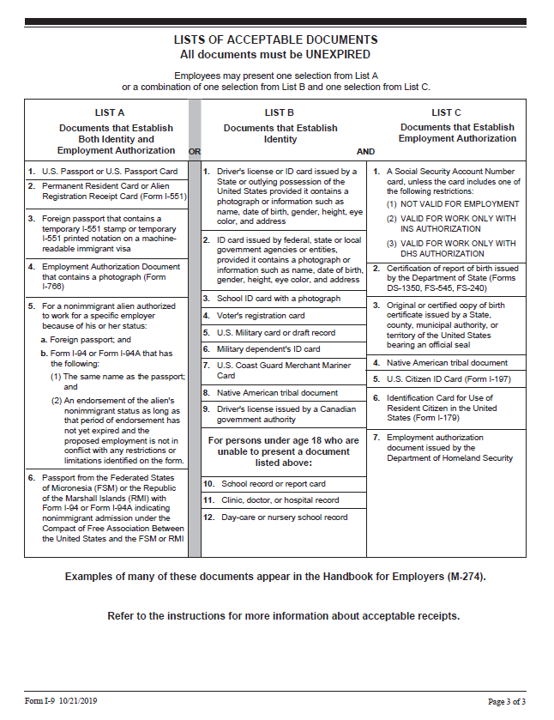

Important Benefits Information for New Employees

Welcome to Washington State University!
Human Resource Services (HRS) has been informed that you have recently been offered employment with WSU. As a new employee, you will have benefit options which need to be addressed, primarily within the first 30 calendar days from your hire date.

New Employee Benefit Information
In an effort to provide you with this information as soon as possible, we would like to direct you to the HRS Benefits website at hrs.wsu.edu/new-employee-information.

This webpage provides valuable information for you to review in order to begin making your benefit decisions. In the event you would like to complete and submit benefit forms early, the forms are also linked on this webpage. Additionally, the New Employee Resources hrs.wsu.edu/new-employee-resources website will provide you with a schedule of the new employee orientations, where helpful information and resources for new employees are provided.

New Employee Benefits Packet
In addition to this web link, HRS Benefits will mail you a new employee packet which will include hard copies of the materials found at the above link. This packet will also include information about your retirement plan options. Although retirement plan resources are available online, please be aware that many factors are used to determine which plan an employee is eligible for. If you wish to address your retirement benefits prior to receiving the packet, please contact HRS at (509) 335-4521 or hrs@wsu.edu.

If you have not received a benefits packet within two weeks of your hire date, please contact HRS immediately. Packets are also available at the HRS office, located in 139 French Administration in Pullman. For locations other than Pullman, please contact us at (509) 335-4521 or hrs@wsu.edu.

Dual Enrollment
In the event you are already enrolled on a spouse’s, registered domestic partner’s, or parent’s Public Employee Benefit Board (PEBB) coverage, dual enrollment in WSU medical/dental coverage is not allowed. Both you and the individual on whom you already have coverage will need to complete benefit paperwork. Additional details will be available in the benefit packet. Contact HRS with questions about dual enrollment, and the paperwork that needs to be completed.

Again, Welcome to WSU! If you have questions please contact Human Resource Services at (509) 335-4521 or hrs@wsu.edu.

