Welcome, INSERT CANDIDATE NAME HERE

Congratulations on making it to the on-site component of this recruitment. We are thrilled to have you visiting us here on the Everett Campus.
Within this packet you will find information regarding your on-site interview with DEPARTMENT NAME, an agenda for the next few days, and background information on Washington State University and its benefits, campus and surrounding area activities.

We truly hope you enjoy your stay, and encourage you to reach out
INSERT PRIMARY CONTACT NAME AND INFORMATION HERE
If you have any questions or concerns

Thank you again, good luck, and we hope you enjoy your time on campus. GO COUGS!

[This page is dedicated to department background information and may contain any information the search committee deems necessary for the candidate]

This page is dedicated to the agenda for the weekend.
On this page be sure to include all of the following:
- Events/Meetings the candidate will be partaking in
- Times and locations with a map/directions
- Transportation options
  - Flying into Seattle International Airport
    - Rental Cars: Rental Cars | Port of Seattle (portseattle.org)
    - Ride share apps: Uber, Lyft, etc
    - Hotel Courtesy Shuttles

About Washington State University- Spokane Campus
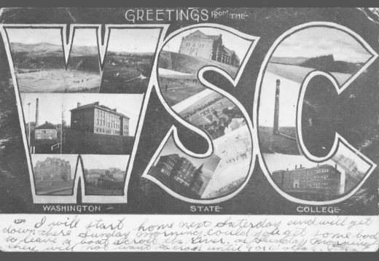
The Morrill Acts of 1862 and 1890 answered demand for practical education that was accessible to agricultural and industrial workers. The legislation granted federally controlled land to the states, which states could then sell to fund establishment of “land-grant” colleges
Washington State College was established in 1890 as a land-grant institution. It has become a distinguished public research university, but its mission remains rooted in accessibility and public service.
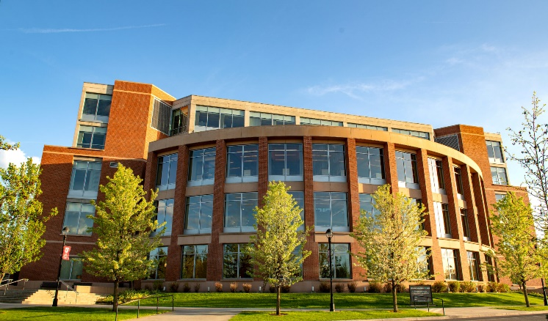
Today Washington State University proudly supports 5 campus locations across the state of Washington and one online Global campus. Across these different campuses WSU offers:
- 101 majors for undergraduates
- 79 masters programs
- 65 doctoral degree
3 professional degree programs
Everett Campus Background
The Everett campus of Washington State University was the last campus to be built and was established in 2014. Due to high education demand within the Puget Sound area, WSU built this community centered campus that allows students the unique opportunity to align world-class WSU academics directly with industry partners.
Today the Everett campus hosts nearly 300 students and provides junior- and senior-level courses in seven high-demand bachelor’s degrees. It also serves as a clinical campus for the Elson S. Floyd College of Medicine based at WSU Spokane.
For additional information on Washington State University please visit to following sites:
- WSU Difference | Washington State University
- Strategic Plan | Office of Strategy, Planning, and Analysis | Washington State University (wsu.edu)
- Washington State University Everett | Washington State University (wsu.edu)

Washington State University Values:
QUALITY AND EXCELLENCE
We are committed to providing quality and excellence in all our endeavors.

INTEGRITY, TRUST, AND RESPECT
We are committed to ensuring trust and respect for all persons in an environment that cultivates individual and institutional integrity in all that we do.

RESEARCH, INNOVATION, AND CREATIVITY
We are committed to the pursuit of inquiry and discovery and to the creation and dissemination of knowledge.

LAND-GRANT IDEALS
We are committed to the land-grant ideals of access, engagement, leadership, and service to bring the practical benefits of education to the state, nation, and global community.

DIVERSITY AND GLOBAL CITIZENSHIP
We embrace a worldview that recognizes and values the importance of domestic and global diversity, global interdependence, and sustainability.

FREEDOM OF EXPRESSION
We are committed to the free exchange of ideas in a constructive and civil environment, including the canons of academic freedom in research, teaching, and outreach.

STEWARDSHIP AND ACCOUNTABILITY
We are committed to serving as ethical and responsible stewards of University resources.

The Washington State University Mission:
To advance knowledge through creative research and scholarship across a wide range of academic disciplines.
To extend knowledge through innovative educational programs in which emerging scholars are mentored to realize their highest potential and assume roles of leadership, responsibility, and service to society.
To apply knowledge through local and global engagement that will improve quality of life and enhance the economy of the state, nation, and world.
Everett Campus/Parking Information
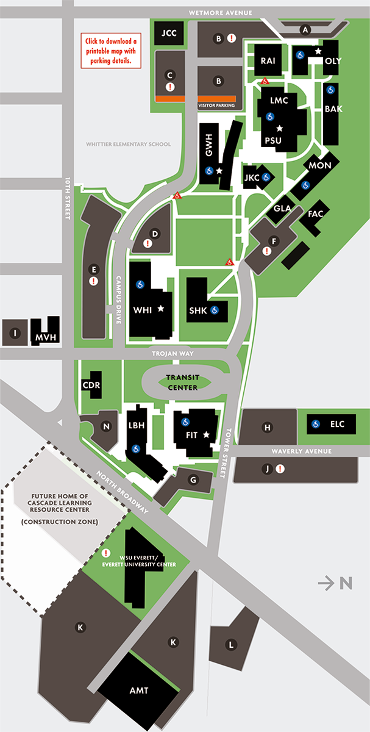
This map highlights where student, staff, visitor, and handicapped parking is located on EvCC's campus. A parking permit is required.
– Please be aware that WSU Everett shares a campus with Everett Community College and you will be directed to their page for parking information.

- Visitor Parking Passes: Visitor Parking | Everett Community College (everettcc.edu)

Washington State University Benefits Overview

Washington State University offers a comprehensive benefits package, encompassing a sizable amount of our employees’ overall compensation package. Options to best fit our employees’ and their families’ needs are offered, and we are happy to extend these benefits to you!

- Medical Insurance: http://hrs.wsu.edu/medical-insurance/
- Premium Surcharges: http://hrs.wsu.edu/premium-surcharges/
- Dental Insurance: http://hrs.wsu.edu/dental-insurance/
- Life Insurance: http://hrs.wsu.edu/life-insurance/
- Long Term Disability: http://hrs.wsu.edu/long-term-disability/
- Dependent Care Assistance Program: http://hrs.wsu.edu/dependent-care-assistance-program/
- Flexible Spending arrangement: http://hrs.wsu.edu/flexible-spending-account/
- Health Savings Account: http://hrs.wsu.edu/health-savings-account/
- Commuter Benefit: https://hrs.wsu.edu/employees/benefits/benefit-details/commuter-benefit/
- Auto& Home Insurance: http://hrs.wsu.edu/auto-and-homeowners-insurance/
- Long-term Care: https://hrs.wsu.edu/employees/benefits/benefit-details/long-term-care-and-the-long-term-services-and-support-trust/
- WA 529 College Savings Plans: https://wastate529.wa.gov/
- Public Service Loan Forgiveness: https://hrs.wsu.edu/employees/benefits/benefit-details/public-service-loan-forgiveness/
- Mental Health Services: https://hrs.wsu.edu/employees/benefits/benefit-details/mental-health-services/

For a more comprehensive overview please refer to these handouts: only include the information for the candidates position!

- Faculty and Administrative Professional Positions: 2022-Benefit-Overview-for-Faculty-and-AP.pdf (wsu.edu)
- Classified Staff: Microsoft Word - 2022 Benefit Overview for Civil Service (wsu.edu)

Welcome to Everett Washington!
Located just 40 minutes north of Seattle sits Everett, Washington, which just so happens to be the 7th largest city in Washington!

