Spokane Candidate Packet Example

Welcome, INSERT CANDIDATE NAME HERE

Congratulations on making it to the on-site component of this recruitment. We are thrilled to have you visiting us here on the Spokane Campus.
Within this packet you will find information regarding your on-site interview with DEPARTMENT NAME, an agenda for the next few days, and background information on Washington State University and its benefits, campus and surrounding area activities.

We truly hope you enjoy your stay, and encourage you to reach out
INSERT PRIMARY CONTACT NAME AND INFORMATION HERE
If you have any questions or concerns

Thank you again, good luck, and we hope you enjoy your time on campus. GO COUGS!

[This page is dedicated to department background information and may contain any information the search committee deems necessary for the candidate]

This page is dedicated to the agenda for the weekend.
On this page be sure to include all of the following:
- Events/Meetings the candidate will be partaking in
- Times and locations with a map/directions
- Transportation options
  - Portland Airport rental cars: FlyPDX - Rental Cars
  - Hotel Courtesy Shuttles from airport: FlyPDX - Courtesy shuttles
  - Portland also have Uber, Lyft and Wings: FlyPDX - Rideshare

About Washington State University- Spokane Campus
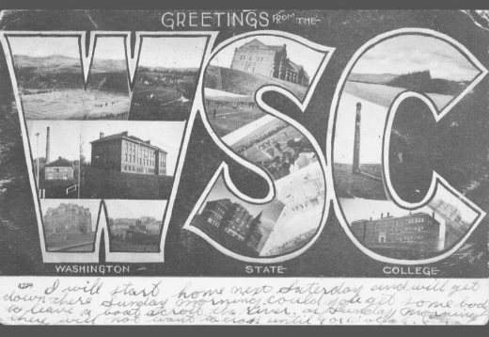
The Morrill Acts of 1862 and 1890 answered demand for practical education that was accessible to agricultural and industrial workers. The legislation granted federally controlled land to the states, which states could then sell to fund establishment of “land-grant” colleges
Washington State College was established in 1890 as a land-grant institution. It has become a distinguished public research university, but its mission remains rooted in accessibility and public service.
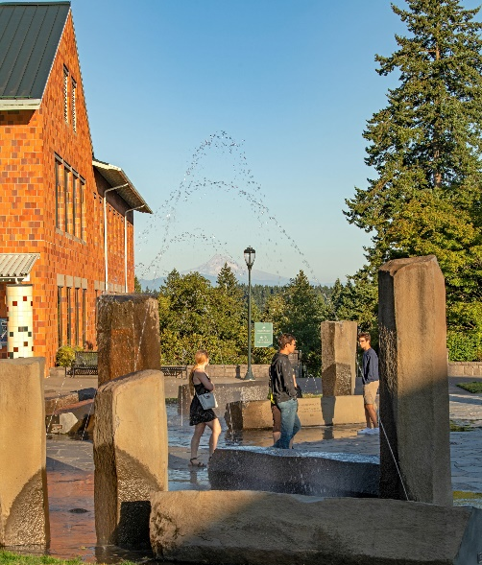
Today Washington State University proudly supports 5 campus locations across the state of Washington and one online Global campus. Across these different campuses WSU offers:
- 101 majors for undergraduates
- 79 masters programs
- 65 doctoral degree
- 3 professional degree programs

Vancouver Campus Background
In 1987 the Higher Education Coordinating Board requested that Washington’s two Universities expand their campuses through the establishment of branch campuses. As a response to this Washington State University created the WSU Vancouver Campus in 1989.
WSU Vancouver established roots within Washington’s Southwest corner just north of the Columbia River. This campus covers 351 beautiful acres along Salmon Creek, and boasts 3 mountain views and an impressive 6 miles of trails for students, staff, faculty and community to use. Today the campus supports 8 different colleges that offers 25 bachelor degrees, 8 master’s degrees and 3 doctorate degrees.
For additional information on Washington State University Vancouver please visit the following sites:
- Washington State University Vancouver - Vancouver, WA, USA (wsu.edu)
- Strategic Plan - - WSU Vancouver
- WSU Difference | Washington State University

Washington State University Values:
QUALITY AND EXCELLENCE
We are committed to providing quality and excellence in all our endeavors.

INTEGRITY, TRUST, AND RESPECT
We are committed to ensuring trust and respect for all persons in an environment that cultivates individual and institutional integrity in all that we do.

RESEARCH, INNOVATION, AND CREATIVITY
We are committed to the pursuit of inquiry and discovery and to the creation and dissemination of knowledge.

LAND-GRANT IDEALS
We are committed to the land-grant ideals of access, engagement, leadership, and service to bring the practical benefits of education to the state, nation, and global community.

DIVERSITY AND GLOBAL CITIZENSHIP
We embrace a worldview that recognizes and values the importance of domestic and global diversity, global interdependence, and sustainability.

FREEDOM OF EXPRESSION
We are committed to the free exchange of ideas in a constructive and civil environment, including the canons of academic freedom in research, teaching, and outreach.

STEWARDSHIP AND ACCOUNTABILITY
We are committed to serving as ethical and responsible stewards of University resources.

The Washington State University Mission:
To advance knowledge through creative research and scholarship across a wide range of academic disciplines.
To extend knowledge through innovative educational programs in which emerging scholars are mentored to realize their highest potential and assume roles of leadership, responsibility, and service to society.
To apply knowledge through local and global engagement that will improve quality of life and enhance the economy of the state, nation, and world.

Vancouver Campus/Parking Information
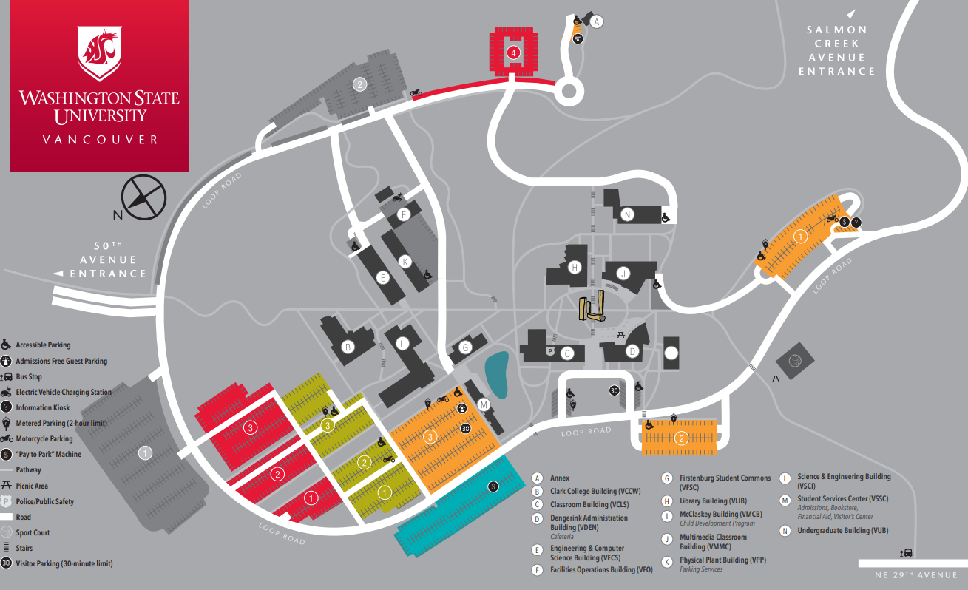
- WSU Vancouver Visitor Parking information: Visitor parking - Parking Services - WSU Vancouver
- WSU Vancouver parking permits: Department of Parking Services
Parking Quick Facts:
- Free 30-minute parking is available near Dengerink Administration Building and Student Services Center.
- Two-hour metered spaces are located in all Orange lots and in Green 3 lot. Meters accept quarters, dimes and nickels; $1.50 per hour. The north bus-loop meters also accept VISA and MasterCard.

Washington State University Benefits Overview

Washington State University offers a comprehensive benefits package, encompassing a sizable amount of our employees’ overall compensation package. Options to best fit our employees’ and their families’ needs are offered, and we are happy to extend these benefits to you!

- Medical Insurance: http://hrs.wsu.edu/medical-insurance/
- Premium Surcharges: http://hrs.wsu.edu/premium-surcharges/
- Dental Insurance: http://hrs.wsu.edu/dental-insurance/
- Life Insurance: http://hrs.wsu.edu/life-insurance/
- Long Term Disability: http://hrs.wsu.edu/long-term-disability/
- Dependent Care Assistance Program: http://hrs.wsu.edu/dependent-care-assistance-program/
- Flexible Spending arrangement: http://hrs.wsu.edu/flexible-spending-account/
- Health Savings Account: http://hrs.wsu.edu/health-savings-account/
- Commuter Benefit: https://hrs.wsu.edu/employees/benefits/benefit-details/commuter-benefit/
- Auto& Home Insurance: http://hrs.wsu.edu/auto-and-homeowners-insurance/
- Long-term Care: https://hrs.wsu.edu/employees/benefits/benefit-details/long-term-care-and-the-long-term-services-and-support-trust/
- WA 529 College Savings Plans: https://wastate529.wa.gov/
- Public Service Loan Forgiveness: https://hrs.wsu.edu/employees/benefits/benefit-details/public-service-loan-forgiveness/
- Mental Health Services: https://hrs.wsu.edu/employees/benefits/benefit-details/mental-health-services/

For a more comprehensive overview please refer to these handouts: only include the information for the candidates position!

- Faculty and Administrative Professional Positions: 2022-Benefit-Overview-for-Faculty-and-AP.pdf (wsu.edu)
- Classified Staff: Microsoft Word - 2022 Benefit Overview for Civil Service (wsu.edu)

Welcome to Vancouver Washington!
During your visit we encourage you to explore Vancouver and the many activities this city has to offer! Vancouver is a beautiful city that offers fun filled activities in every season! Enjoy delicious restaurants, explore diverse galleries and museums or get outdoors and visit one of the many scenic parks or riverfront walkways!
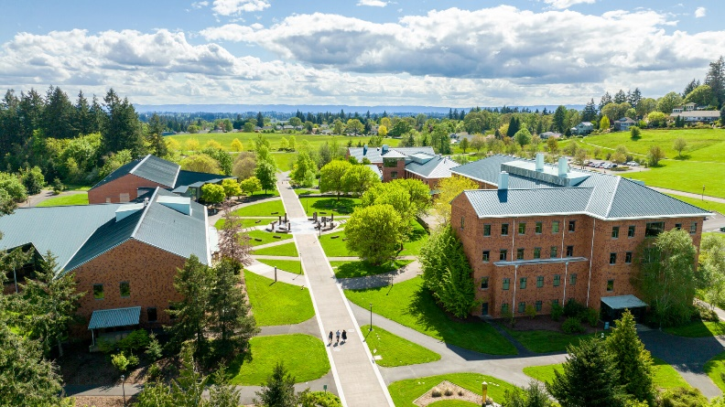
Below you will find links to the many options Vancouver has to offer!
- Overview of Vancouver, WA: Visit Vancouver Washington
- Vancouver Dining: Places To Eat & Drink in Vancouver, WA | Local Guide
- Historical Sites: Historic Sites in Vancouver WA
- Local shopping and farmers markets: Shopping in Vancouver WA
Walk along the beautiful waterfront area, where you can experience fresh seafood, visit the pier or walk the many trials and bridges this area has to offer: Vancouver, WA Waterfront
Vancouver also plays host to numerous events and celebrations throughout the year and can found here: Vancouver WA Events | Festivals, Concerts & Special Events
Living in Vancouver, Washington
- Vancouver School Districts: Vancouver Public Schools
- Vancouver Private Schools: Private Schools - Vancouver, WA

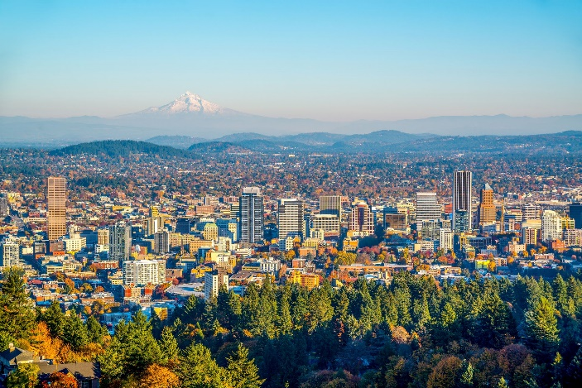
If you are interested in venturing outside Vancouver, just across the river is vivacious Portland Oregon. Similar to Vancouver, Portland offers a high diversity of restaurants, shops, hiking trails and events for you to explore!

- Take a cruise along the Columbia River: Portland Spirit Cruises & Events | Portland, Oregon
- Explore the “neighborhoods” of Portland: Neighborhoods | The Official Guide to Portland
- Portland Dining Recommendations: Food | The Official Guide to Portland

